Project Development Phase – Sprint 2

|  |  |
| --- | --- |
| Date | 31 October 2022 |
| Team ID | PNT2022TMID22202 |
| Project Name | A new hint to transportation – Analysis of the NYC bike share system. |
| Maximum Marks | 20 Marks |

# Feature Engineering:

**calculating Age from birth year** from datetime import datetime, date age=2018-df['birth_year'] df['Age']=age

df.head()

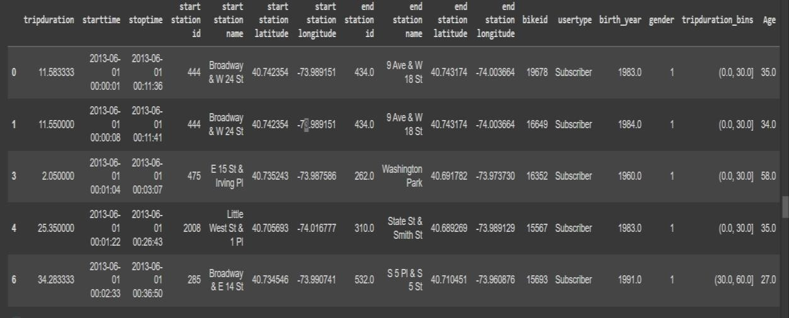

**calculating age group from age** max_limit = df['Age'].max() max_limit

bins = [0,20,40,60,max_limit]

agegroup = pd.cut(df['Age'], bins=bins).value_counts()

Agegroup

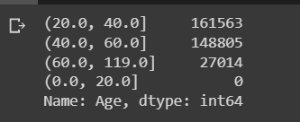

# calculating hour

peak_hour['Start Date'] = pd.to_datetime(df['starttime']) peak_hour['Stop Date'] = pd.to_datetime(df['stoptime']) peak_hour['year'] =peak_hour["Start Date"].dt.year peak_hour["Hour"] = peak_hour["Start Date"].dt.hour

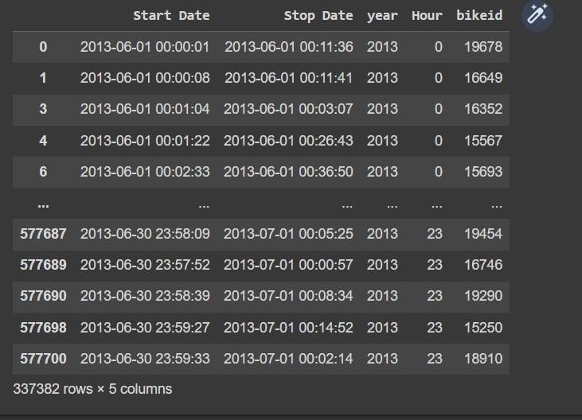

# Visualization of the dataset in COGNOS Platform: Finding the number of trips per each bike:

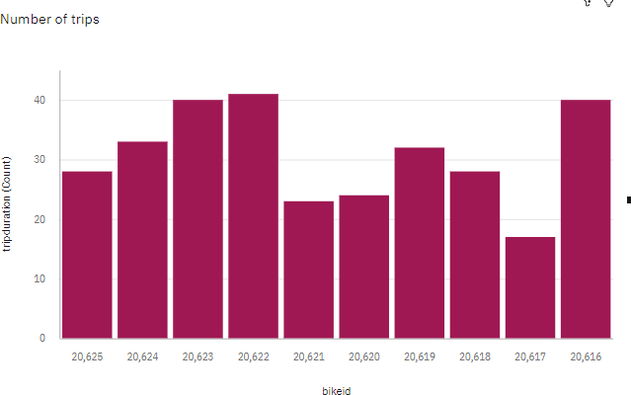

**Finding the percentage of customers and subscribers**

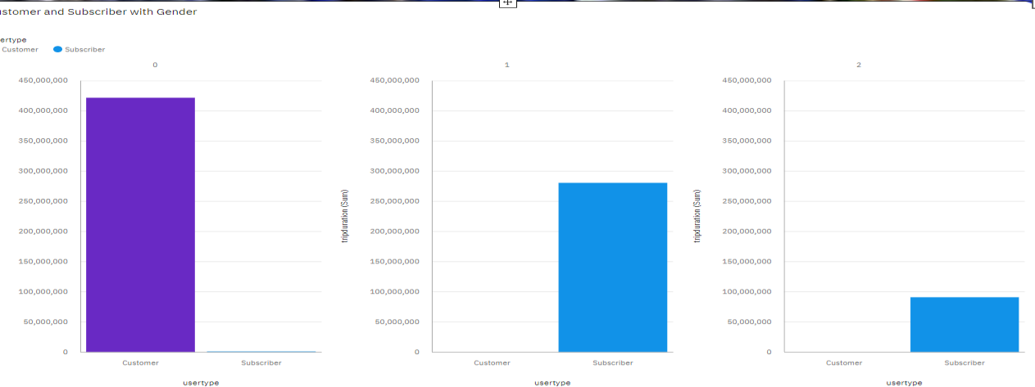

**Bike Usage - Bike Id Vs Trip Duration:**

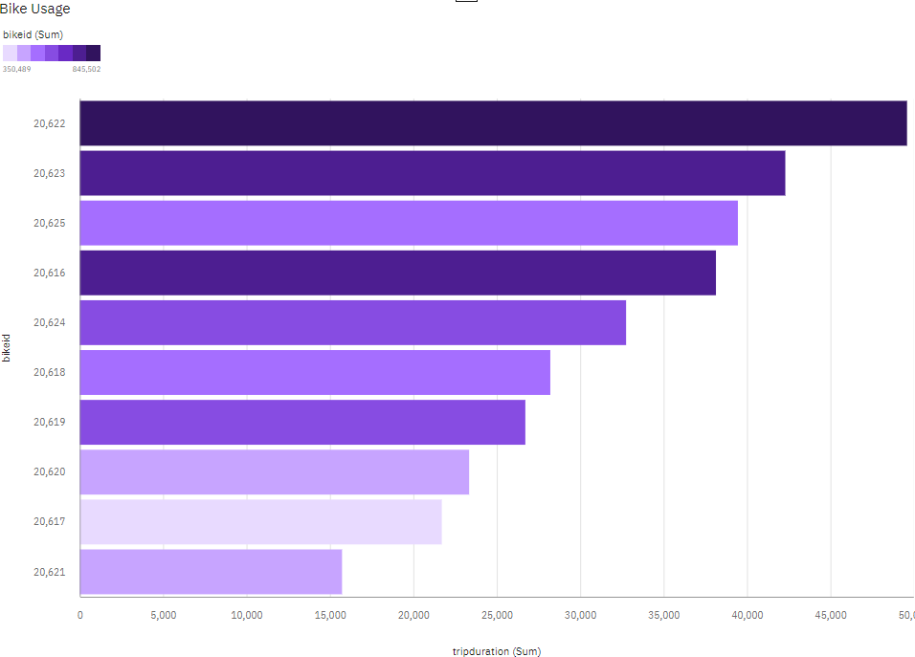

# Age Group Differentiation by BikeId: Calculation:

if(age<=20) then ('<20')

else if(age>=21 and age<=30) then ('21-30')

else if(age>=31 and age<=40) then ('31-40')

else if(age>=41 and age<=55) then ('41-55')

else('>55')

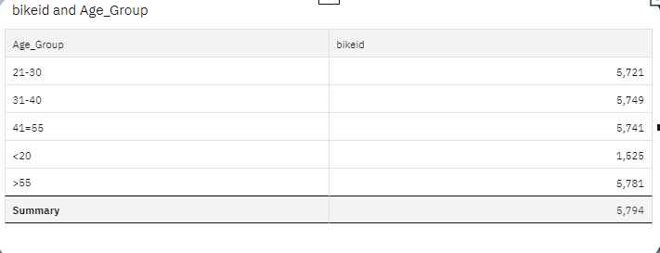

# Finding the top 10 start stations with customer age group:

